

RESOURCES – WORKBOOK
COMPUTER NETWORK
student nAME: TIwouw, Joseph JANONE
inSTRuctor: Jimmy MoedjaHEDY
Universitas Klabat
airmadidi-minahasa utara
Version 1.5

RESOURCES – WORKBOOK
COMPUTER NETWORK

wINDOWS SERVER 2012

goal
- DHCP SERVER SETTING ON WINDOWS SERVER 2012

LIST OF ACTIVITIES
 | Activities
1. | Config DHCP Server
2. | Screen Shot your config
 | IP Range = 30 IP or more (server IP: 192.168.1.1)
4. | Screen Shot list of clients that get IP from DHCP server from “address Leases”
5. | Try to ping the server and access the web (using DNS) from client (your friend machine). Screen shot your IP Address using “ipconfig /all” using command prompt, side by side with accessing domain from your friend machine

Concept:
DHCP (Dynamic Host Configuration Protocol) is a communications protocol that network administrators use to centrally manage and automate the network configuration of devices attaching to an Internet Protocol (IP) network.
DHCP allows devices needing an IP address to request one when they are starting up, for example, rather than an address preassigned and manually configured on each device. With DHCP, if a device is moved from place to place, it will be assigned a new address in each location. Without DHCP, network administrators must not only manually configure each device with a valid IP address, but also reconfigure the device with a new IP address if it moves to a new location on the network. DHCP exists for both IPv4 and IPv6 (Internet Protocol version 6).
Devices reach out to the local network to discover any available DHCP server and request network configuration information. Servers manage pools of valid addresses and assign addresses out of those pools. DHCP uses the concept of leasing the amount of time a given IP address will be valid for a device. The lease time can vary depending on how long a user is likely to require the Internet connection at a particular location. Devices release addresses when their leases expire and request a renewal from the DHCP server if they are staying online. The DHCP server may assign them a new address rather than renewing an old one. The protocol also supports static addresses for computers like Web servers that need a permanent IP address.

Answer sheet for a. Config DHCP server
2.
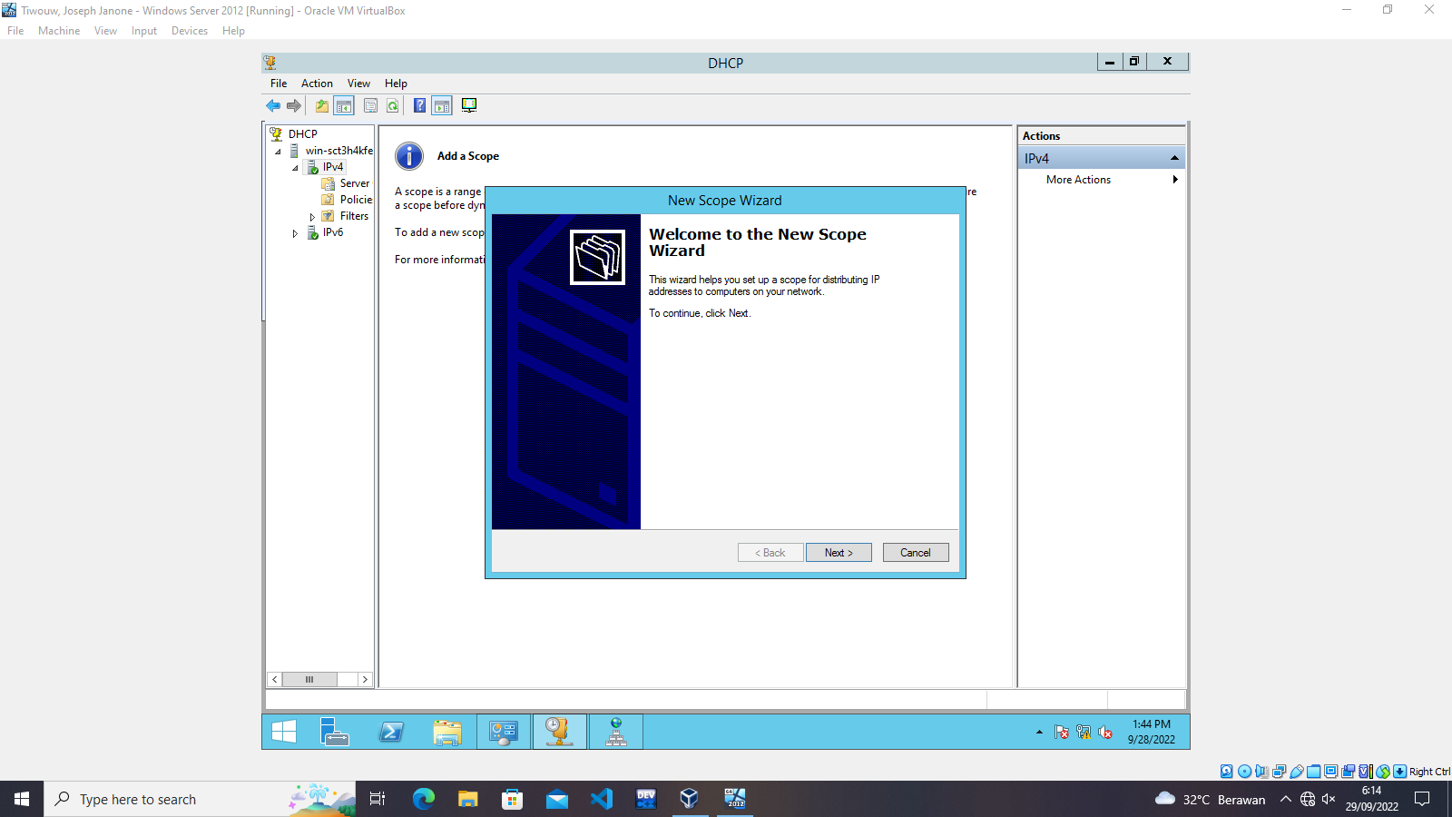
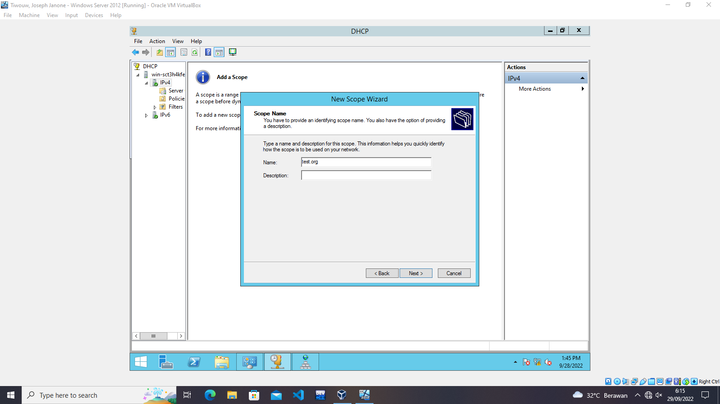

3.
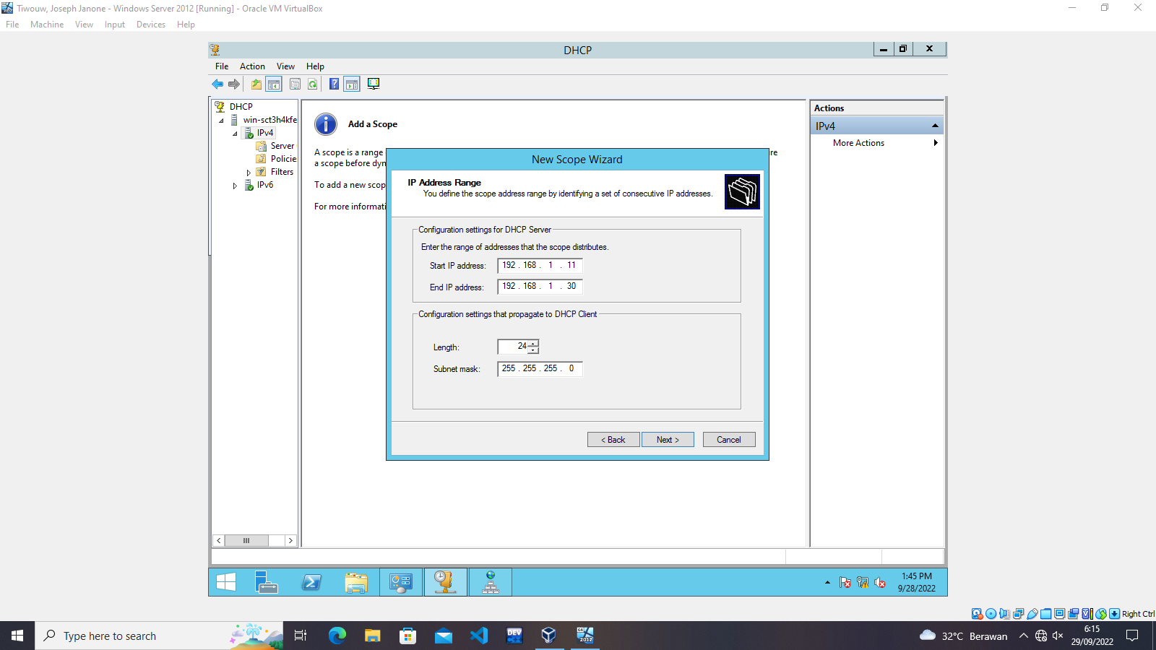
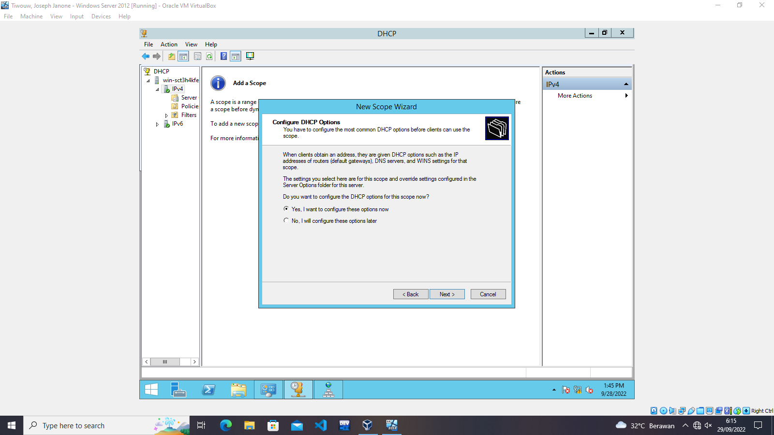

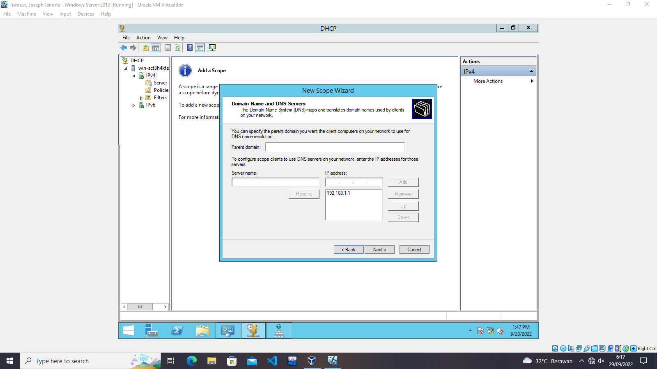

5.
